OUT-PATIENT PHYSIOTHERAPY – SELF REFERRAL FORM

Please complete this form as fully as possible.

Please see our website at www. https://www.mskphysiogrampian.scot.nhs.uk or via

Full name: |  | Today’s date:
Date of Birth: | (must be 16yo and over) | Home tel no:
Address: |  | Work tel no:
 |  | Mobile no:
Postcode: |  | GP name/address:
Male: | Female:

Occupation/Carer/Veteran

Are you off work because of this problem? Yes No Not applicable

Please use body chart to identify problem area  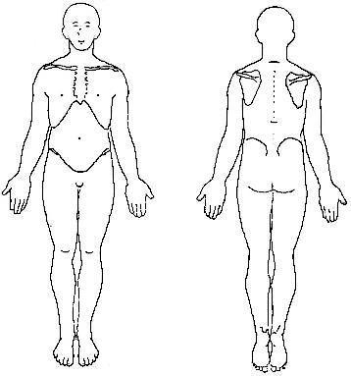  If you are experiencing pins and needles, numbness or weakness please describe where.  If typing form please describe your pain area | Please describe your current symptoms
How long have you had this problem?
0 – 2 wks 2 – 12 wks > 12 wks repeated episodes/had before

 | Since the problem began is it? Worsening Same Improving
If you are experiencing pain, would you rate it as
Mild Moderate Severe And Constant Intermittent

Are you taking any medication for your pain? No
Yes please list
Is pain disturbing your sleep?
Yes, unable to sleep Yes, wakening from sleep No
Any day to day activities you are unable to do? No
Yes Please list

 | Has anything helped the symptoms to date? Have you had previous physiotherapy treatment for the problem? Have you attended Orthopaedics, Pain, Rheumatology or any other service with this problem?

Any special requirements (eg interpreter/hard of hearing or deaf)?
It is important that you complete this form as fully as possible. Please check over the information you have provided. Please note we cannot take responsibility for any information that has been withheld.
I agree that the information that I have provided in this form is accurate and may be shared with my GP.
I consent to relevant medical information being released from my GP if required.
Signature: Date:
What happens next?
Your completed form should be posted to The MSK Referral Centre, First Floor, Ward 6, Woodend Hospital, Eday Road, Aberdeen, AB15 6XS or via e-mail at gram.mskreferralcentre@nhs.scot

What should I do if my problem gets worse while I am waiting for an appointment?
If you feel your problem is worsening and you have concerns about your problem then you should contact your GP or NHS 24 (08454 24 24 24). You should do this urgently if you have recently, or suddenly, developed
- Difficulty passing urine or controlling bladder/bowels
- Numbness or tingling around your back passage or genitals
- Numbness, pins and needles or weakness in both legs
Please note that if you have a continence problem and have any bleeding from either your front or back passages then please see your GP first.

How are physiotherapy services running during COVID?
At present the majority of our initial and follow up consultations are being undertaken by telephone or video consultation. This is likely to be the case for some time. If you are asked to attend an appointment please note that we are adhering to social distancing rules, hand hygiene and infection control procedures. Please do not attend the department if you are feeling unwell or are experiencing any symptoms of COVID-19.
How long will I have to wait before I am offered an appointment?
A physiotherapist will look at your form and an appointment will be planned based on the information you have supplied. Depending on the nature of your problem you may be placed on a waiting list for physiotherapy. The waiting time for physiotherapy varies depending on the demands on the service.
How will I be contacted?
You will either be sent a letter asking you to contact the department to arrange an appointment or someone may telephone you to arrange it. Please ensure all your contact details have been included on this form including a day-time telephone number. We may leave a message on your telephone, please tick the box is you do not want us to leave a message .
Will the information I have provided be shared with anyone else?
Sometimes we may need to contact your GP if we require further information to help us decide if physiotherapy is appropriate for you. If you are seen by the physiotherapist your GP will be informed of this.
Can the physiotherapist see me at home?
If you are unable to attend out-patients for any medical reason you can be referred by your GP to the Domicillary services.

